

COMP8157-5-R-2022W: Advanced Database Topics

# Project Milestone I

# Submitted to:

**Dr. Kalyani Selvarajah**

**Submitted by:**

Eswaran Badrinarayanan Venkateswaran – 10069235

Hani Pankajkumar Bhavsar – 110072568

Vishal Jayaraman - 110067134

**Project Overview:**

The management of the flow of goods and services has been largely transformed by automation software. However, there has always been a persisting mismatch between supply and demand globally, leading to an imbalance in a company's inventory management.​ As a result, small-scale businesses need to retrieve employee's work record through Query Optimization techniques to enhance overall production rate of resource

**Work Breakdown Structure (WBS)**

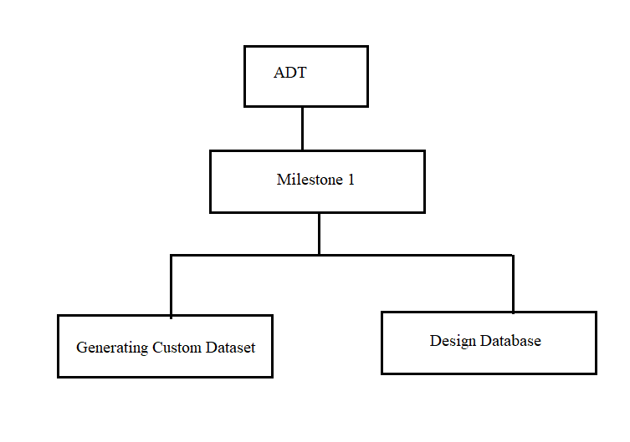

**Generating Custom Dataset:**

Python libraries such as faker and pandas were used in this project.

Faker is an open-source python package that allows users to create dummy datasets, or random data containing random attributes such as names, ages, localities, and so on.

Pandas is a popular open-source Python package used for data science, data analysis, and machine learning. Pandas simplify several time-consuming, repetitive data-processing tasks, such as data normalization, merges and joins, data visualization, statistical analysis, data inspection, and data loading and storing. In this project package is primarily used to generate dataframes and export them into spreadsheet format, which can then be imported into a database.

With the help of the above-mentioned libraries a python script was written to generate huge number of dummy data.

**Database design:**

Microsoft Sql Server is used in this project.

The main purpose of the database is to fetch the data of employee that are required to calculate the efficiency of the employee over a given period of time. Because the data is time series data the volume of the data is huge.

Therefore, the design of the database should be in such a way that

1. The database should be normalized to the maximum level

2. Implementation of query optimization is possible.

By taking the above-mentioned conditions into consideration the database was designed.There are three tables with the respective attributes in the database.

1. Employee - EID(Primary Key), Name, Contact

2. Product - PID(Primary Key), Name, Description

3. production - Date_of_Production, EID(Foreign Key), PID(Foreign Key), Produced_Quantity, Total_Quantity, Work_hours(Date_of_Production, EID(Foreign Key), PID(Foreign Key)(Primary Key)

The ER diagram is also provided.

**Challenges:**

There were several challenges encountered throughout the project's implementation.

Organizations, governments, clicks, online servers, business partners, and even the human body generate data. However, no data was accessible online since the project was one-of-a-kind and only served as a simple demonstration of query optimization in SCM databases. As a result, dummy data was developed, which is not as realistic as a real-time dataset.

Even while the waterfall approach is the greatest fit for this project, it does present some issues. The waterfall model is fully based on a step-by-step approach to project management. This provides very little flexibility for future modifications. It is very difficult to execute an unanticipated modification in the future.

It is risky to delay the testing phase till the end of a project, yet Waterfall forces teams to wait until the last step to test their products. The code will be tested later, when the queries have been optimized. Because the project has most likely taken the assigned amount of time to finish, major adjustments might create severe delays.

.

**References:**

* Services, S. B. T. M. (2021, December 15). *Key Small Business Statistics*. SME research and statistics. Retrieved March 13, 2022, from https://www.ic.gc.ca/eic/site/061.nsf/eng/h_02689.html
* Overview of the food and beverage processing industry - agriculture.canada.ca. (2021, October 28). Agriculture Canada. <https://agriculture.canada.ca/en/canadas-agriculture-sectors/food-processing-industry/overview-food-and-beverage-processing-industry>
* Yevtushenko, A. (2019, April 24). Supercharge Your SQL Queries for Production Databases. Sisense. <https://www.sisense.com/blog/8-ways-fine-tune-sql-queries-production-databases>
* <https://openlibrary-repo.ecampusontario.ca/jspui/handle/123456789/247>
* Gunjal, Bhojaraju. (2003). Database System: Concepts and Design.
* Thalheim, Bernhard. (1993). Database Design Strategies. 267-285. 10.1007/978-3-7091-2704-9_14.
* Sheakh, Dr.Tariq. (2018). A Study of Inventory Management System Case Study. Journal of Dynamical and Control Systems. 10. 1176-1190.
* Plinere, Darya & Borisov, Arkady. (2015). Case Study on Inventory Management Improvement. Information Technology and Management Science. 18. 10.1515/itms-2015-0014.
* Anulika, Nwafor & A, Idoko & Agbo, Jonathan & Emeka, Nnaemeka. (2020). Design and Optimization of An Inventory Management System for Central Stores. International Journal of Innovative Research and Development. 05. 119.